**GAME IDEA 1:** Dungeon Swarm

**Concept:**  
A top-down Role-Playing Game that has the player attempting to survive as long as possible.

**Gameplay:**  
The game will have a timer that tells the player how long they have survived so far.  
Enemies will periodically spawn and approach the player, who must use their weapons:  
1. A sword that has a short range but higher damage, and  
2. A bow that does ranged attacks but is limited in damage and ammunition.  
 NOTE: There will be pickups available to increase the damage and speed of the player  
The Enemies will also periodically get stronger as the time progresses, making it important for the player to collect the pickups.  
The final score will comprise of the time survived and the number of enemies defeated.

**Core Mechanics:**  
2-Dimensional Movement – By WASD/Arrow Keys  
Basic Interactions – ‘Mouse’ to Attack, ‘LeftShift’ for stats, etc.  
Health and Ammunition tracking  
Weapon Attack stat tracking  
Raycast for interaction, attacking, etc.  
UI showing Time and Number of enemies defeated

**Minor Mechanics/Logic:**

UI showing Health and Ammunition on screen  
Pause Menu (Resume, Main Menu, Volume Control, Quit)  
Main Menu (Play, Volume Control, Quit)

**Out of scope mechanics:**

Multiplayer Functionality   
Boss Enemy after a number of enemies have been killed  
2 Levels  
Magic  
UI showing Stats when a button is pressed

**Inspirations/similar works:**

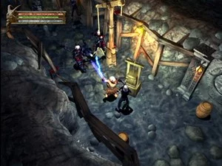- Baldur’s Gate: Dark Alliance

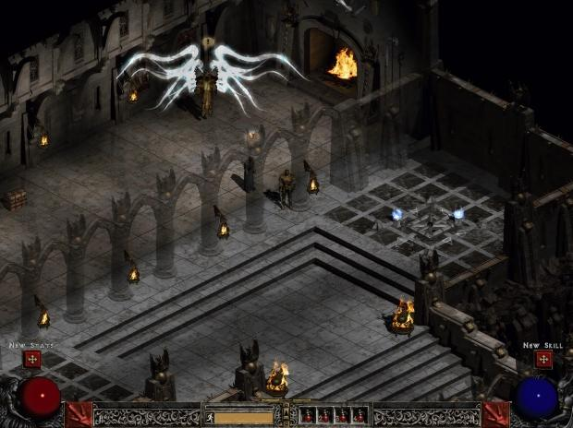 - Diablo 2

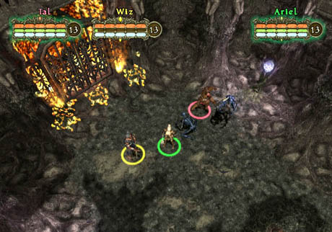 - Champions of Norrath

**Development challenges:**

Making the Pause UI so it will exit the game or restart when the button is pressed  
Adding Textures to the game   
Size of the game, will need dedication and appropriate time management.  
Animations